# **Safety and Risk Management System (SRMS)**

## Overview

The objective of the SRMS is to make the safety and risk management simple and easy. SMRS provide the state of the art features to provide the transparency of the safety and risk rated issue between different parties and to minimize the pain & increase the productivity of the safety officer day-to-day operation.

## Features

1. User Management Module
   * The system allow CURD for the user
   * The System have multiple role such as
     1. Super admin - only one user in the system who can manage the whole site administration
     2. Administrator - a group of administrators who will help the super admin to help the day to day operation and feature upgrading, configuration of the system.
     3. Safety officer – end user of the system who can create the folder, upload the file, share the file (in other word, submit the file), accept and reject the file with feedback.
     4. Auditor – end user of the system who can accept and reject the file with feedback.
2. Permission Management Module
   * The system allow CURD for the role.
   * The system allow the Super admin and Administrator to define the permission of the feature on particular module for each user role.
3. File/Folder Management Module
   * The system allow CURD for File/Folder.
   * There have two type of file repository
     1. System repository – only the system admin and administrator can upload and publish the file and folder as public.
     2. Personal repository - each user have their own repository and they can share to the other user as dropbox, googledrive and so on.
4. Workflow Management Module
   * User (safety officer) can share (i.e. submit) the file to the other user
   * The other user can review the file.
   * After that, they can accept and reject the submission with comment.
   * Also they can submit this particular accepted file to other parties.
5. Security and Performance
6. User interaction and User experience.

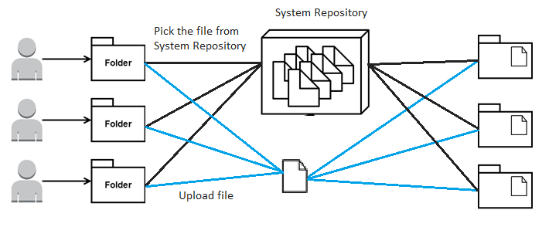

Figure. File/Folder Management Module

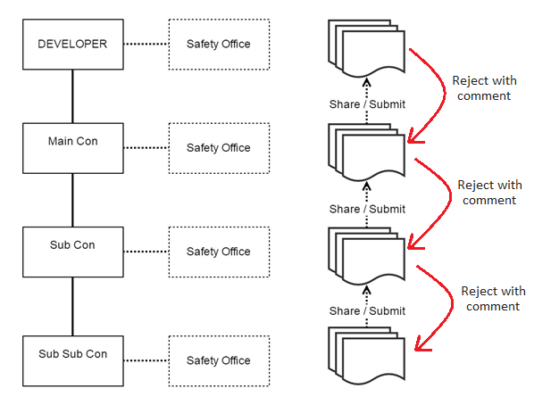

Figure. Workflow Management Module